

**Đặng Hoàng Nguyên – SE171946**

**Packet Tracer - Logging Network Activity**

# Addressing Table

|  |  |  |
| --- | --- | --- |
| **Device** | **Private IP Address** | **Public IP Address** |
| FTP_Server | 192.168.30.253 | 209.165.200.227 |
| SYSLOG_SERVER | 192.168.11.254 | 209.165.200.229 |
| Router2 | N/A | 209.165.200.226 |

# Objectives

**Part 1: Create FTP traffic.**

**Part 2: Investigate the FTP Traffic Part 3: View Syslog Messages**

# Background

In this activity, you will use Packet Tracer to sniff and log network traffic. You will view a security vulnerability in one network application, and view logged ICMP traffic with syslog.

# Instructions

**Part 1: Create FTP traffic.**

**Step 1: Activate the sniffing device.**

1. Click on sniffer device **Sniffer1**.
2. Go to the **Physical** tab and turn on the power to the sniffer.
3. Go to the **GUI** tab and turn the sniffer service on.
4. The FTP and syslog packets entering the sniffer from Router2 are being monitored.

**Step 2: Remotely connect to the FTP server.**

1. Click on **PC-B** and go to the desktop.
2. Click **Command Prompt**. From the command prompt, open an FTP session with **FTP_SERVER** using its public IP address. Help with the command line is available by typing **?** at the prompt.
3. Enter the username of **cisco** and password of **cisco** to authenticate with the **FTP_Server**.

**Step 3: Upload a file to the FTP server.**

1. At the **ftp>** prompt, enter the command **dir** to view the current files stored on the remote FTP server.
2. Upload the **clientinfo.txt** file to the FTP server by entering the command **put clientinfo.txt**.
3. At the **ftp>** prompt, enter the command **dir** and verify that the **clientinfo.txt** file is now on the FTP server. d. Enter **quit** at the FTP prompt to close the session.

© 2018 - 2020 Cisco and/or its affiliates. All rights reserved. Cisco Public Page **1** of **2** www.netacad.com

**Packet Tracer - Logging Network Activity**

# Part 2: Investigate the FTP Traffic

1. Click the **Sniffer1** device and then click the **GUI** tab.
2. Click through some of the first FTP packets in the session. Be sure to scroll down to view the application layer protocol information in the packet details for each. (This assumes this is your first FTP session. If you have opened other sessions, clear the window and repeat the login and file transfer process.)

Questions:

What is the security vulnerability presented by FTP?

**It shows all the password and username when enter into the service.**

What should be done to mitigate this vulnerability?

**We can use SFTP instead of FTP it would be more secure**

# Part 3: View syslog Messages

**Step 1: Remotely connect to Router2.**

1. From the **PC-B** command line, telnet to **Router2**.
2. Use the username **ADMIN** and password **CISCO** for authentication.
3. Enter the following commands at the router prompt:

## Router2# debug ip icmp

d. Type **logout** at the prompt to close the Telnet session.

**Step 2: Generate and View the syslog Messages.**

1. Click on the **SYSLOG_SERVER** device and go to the **Services** tab.
2. Click the **SYSLOG** service. Verify that the service is on. Syslog messages will appear here.
3. Go to host PC-B and open the **Desktop** tab.
4. Open the **Command Prompt** and **ping** Router2.
5. Go to host PC-A and open the **Desktop** tab.
6. Go to the Command Prompt and **ping** Router2.
7. On the syslog server investigate the logged messages.
8. There should be four messages from PC-A and four PC-B.

Questions:

Can you tell which echo replies are for PC-A and PC-B from the destination addresses? Explain.

***They have the same address because NAT allow one or more private IP change to 1 together IP through router and send to server***

1. **Ping** Router2 from PC-C.

Question:

What will the destination address for the replies be?

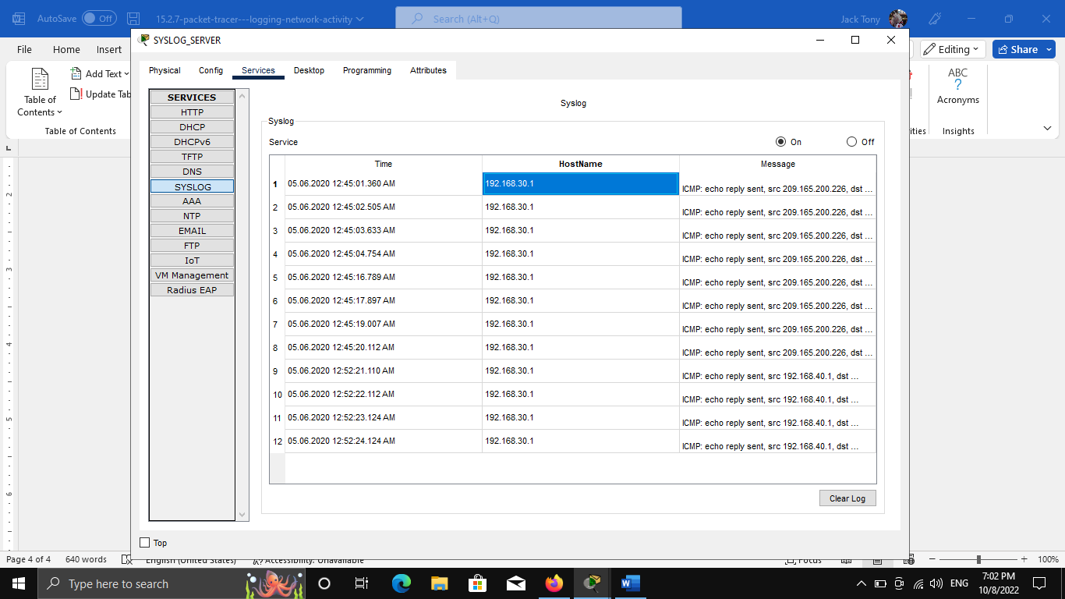

***It will reply the ip of PC-C***

*End of document*

© 2018 - 2020 Cisco and/or its affiliates. All rights reserved. Cisco Public Page **2** of **2** www.netacad.com